USE CASE DIAGRAM
This diagram visualizes the features you implemented, including the new "View Fleet Status" for Admins.

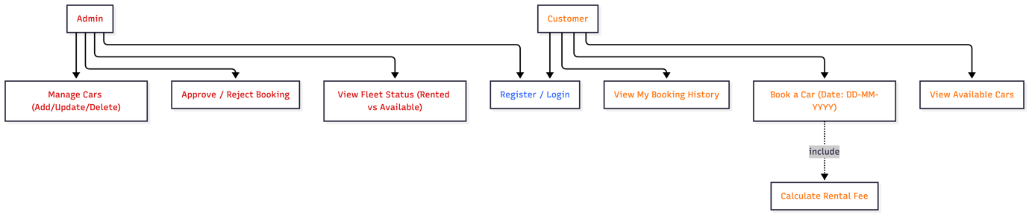

The Use Case Diagram highlights the distinct roles of the Customer and Admin. Customers can browse availability and initiate bookings using the DD-MM-YYYY date format. The Admin role has been enhanced with a 'View Fleet Status' capability to monitor real-time vehicle availability, alongside standard fleet management and booking approval functions.

CLASS DIAGRAM
This diagram reflects your Object-Oriented implementation, showing the Singleton, Factory, and Inheritance patterns present of the code.

.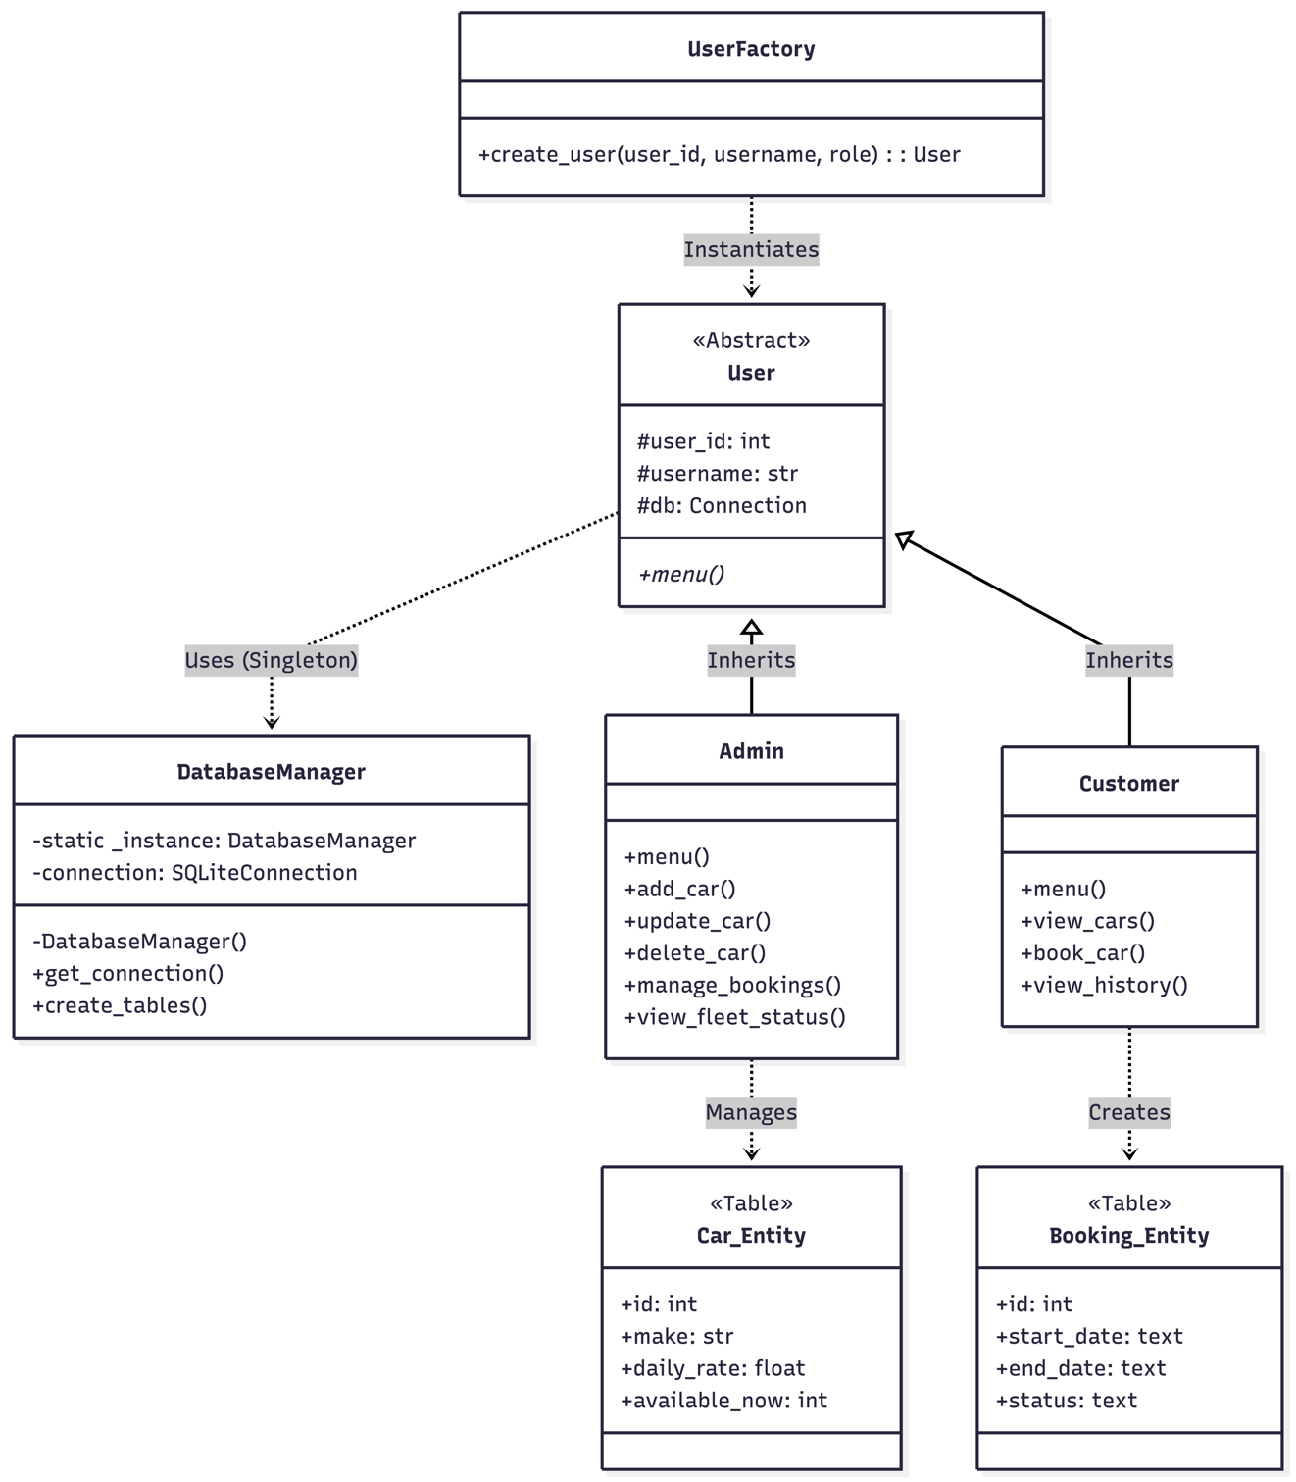
The Class Diagram demonstrates the architectural patterns used. The DatabaseManager uses the Singleton Pattern to ensure a single shared database connection. The UserFactory implements the Factory Pattern to separate user creation logic. Admin and Customer classes demonstrate Inheritance and Polymorphism by implementing the abstract menu() method differently."
Sequence Diagram (The Booking Process)
This diagram traces the specific logic in the book_car() method, including the new Date validation and Fee calculation.

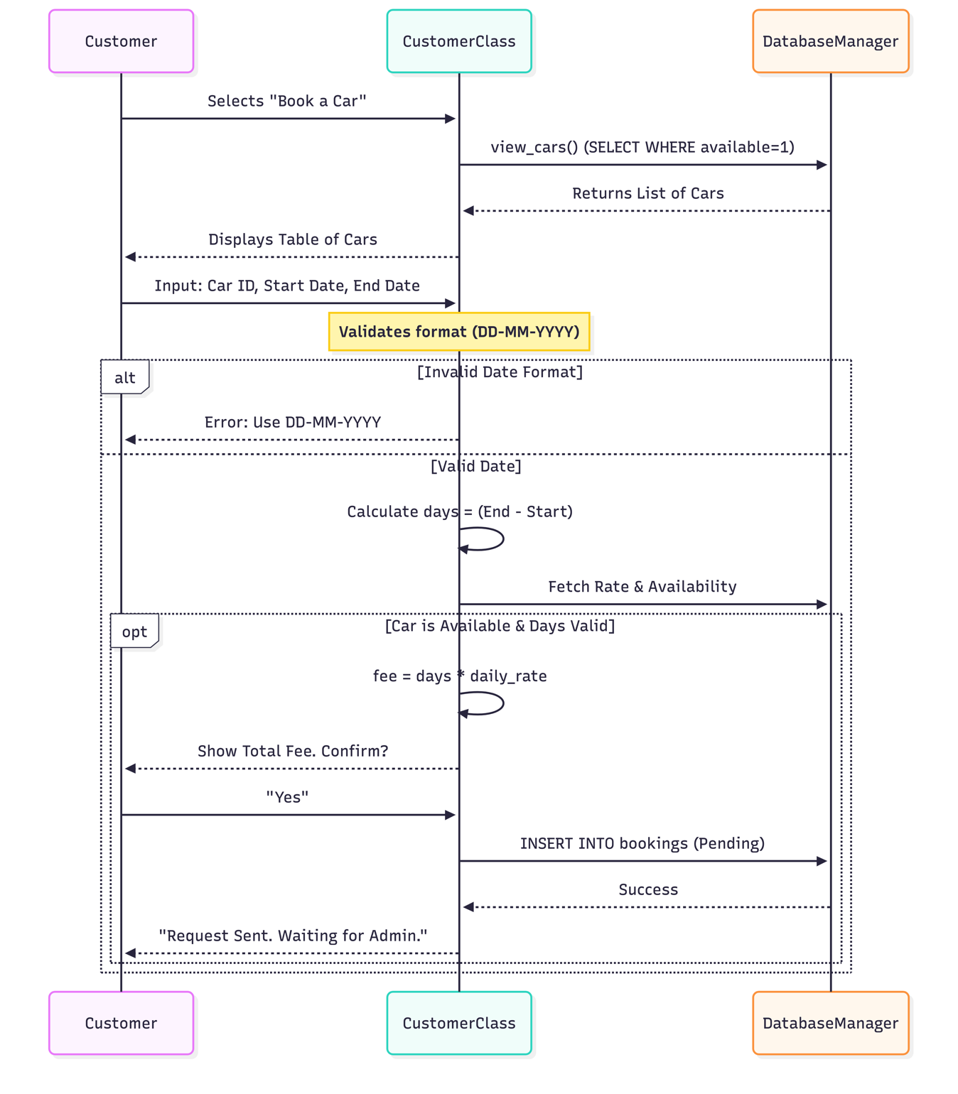
The Sequence Diagram models the control flow of the book_car method. It details the input validation step where the system parses the 'DD-MM-YYYY' string. If the date logic holds (end date > start date), the system queries the Singleton Database Manager to retrieve the daily rate, calculates the total fee, and commits the booking with a 'Pending' status.

